**AIM:**

Write a C program to find Odd or Even number from a given set of numbers

**ALGORITHM**

• **Start**

• Read the total count of numbers n.

• Repeat steps 4–6 for each number from 1 to n:

* Read the number num.
* If num % 2 == 0, then print num is Even.
* Else, print num is Odd.

• Continue until all numbers are checked.

• **Stop**

**CODE**

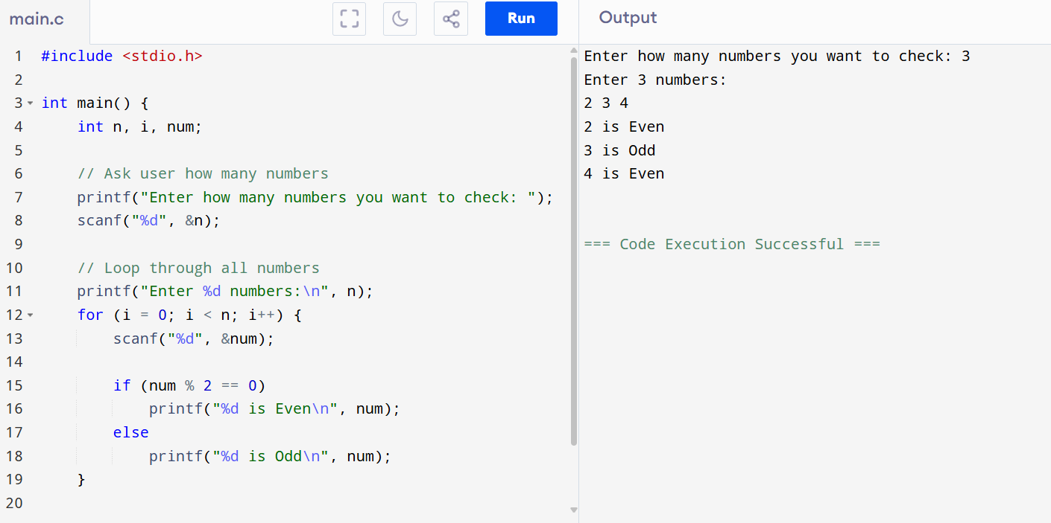

**OUTPUT**

Enter how many numbers you want to check: 3

Enter 3 numbers:

2 3 4

2 is Even

3 is Odd

4 is Even